You have a grid of size n x 3 and you want to paint each cell of the grid with exactly one of the three colors: **Red**, **Yellow,** or **Green** while making sure that no two adjacent cells have the same color (i.e., no two cells that share vertical or horizontal sides have the same color).

Given n the number of rows of the grid, return *the number of ways* you can paint this grid. As the answer may grow large, the answer **must be** computed modulo 109 + 7.

**Example 1:**

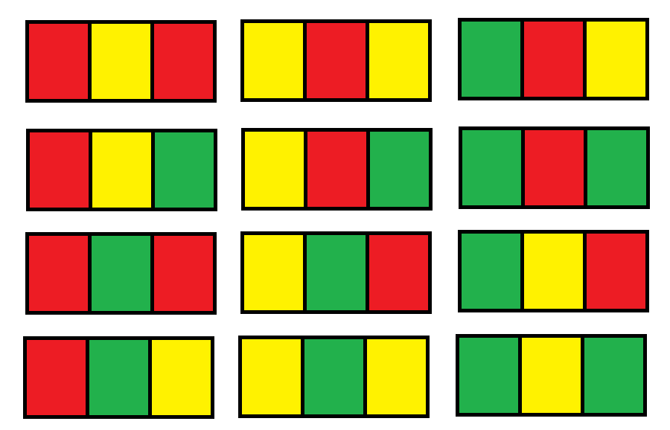

**Input:** n = 1

**Output:** 12

**Explanation:** There are 12 possible way to paint the grid as shown.

**Example 2:**

**Input:** n = 2

**Output:** 54

**Example 3:**

**Input:** n = 3

**Output:** 246

**Example 4:**

**Input:** n = 7

**Output:** 106494

**Example 5:**

**Input:** n = 5000

**Output:** 30228214

**Constraints:**

* n == grid.length
* grid[i].length == 3
* 1 <= n <= 5000